Penn State Newhall Simulation Model

Software Design Specification

Version 1.1

14 April 2010

Center for Environmental Informatics  
Pennsylvania State University

**Revisions**

|  |  |  |  |
| --- | --- | --- | --- |
| Version | Date | Author | Description |
| 1.0 | 10 Feb 2010 | B. Bills | Original version. |
| 1.1 | 14 Apr 2010 | B. Bills | Added Appendices B, C, and D; revised architecture to use single NSM file; added user profile set-up; edits from first review. |
|  |  |  |  |
|  |  |  |  |

Contents

Purpose 1

References 1

Overview 1

System Architecture 1

Input Data 2

Newhall Client 2

NSM XML File (input) 2

Newhall Model 2

NSM XML File (input+output) 2

Information Products 2

User-System Interactions 2

Set-up and Run New Single Model Job 2

Edit Existing Single Model Job 3

Set-up and Run a New Batch of Model Jobs from a Spreadsheet 3

Run a Batch of Existing Model Jobs 4

Create Formatted Outputs from a Model Output File 4

Create/Edit User Profile 4

Workflow for Different Data/Run Scenarios 4

Processing Flow & System Interactions 5

Formatted Outputs/Information Products 5

Job Summary 5

Report 6

Climograph 7

Data Exports 8

Client GUI Prototypes 8

Appendix A: Glossary 10

Appendix B: Input Batch Data File Format 11

Appendix C: NSM Model File Element Descriptions 13

Appendix D: Example NSM XML File 15

# 

# Purpose

This document describes the design of the Penn State Newhall Simulation Model (psuNSM) software to be developed by the Penn State Center for Environmental Informatics. The document provides an overview of the system's major components and architecture, as well as specifications on the interaction between the system and the user.

# References

*Penn State Newhall Simulation Model (psuNSM) Functional Requirements, February 2010**.*

# Overview

This application will run the Newhall Simulation Model as defined by the algorithms developed by Van Wambeke in his original BASIC implementation. The model may be run in either an interactive, or batch mode. Model metadata and results will be presented as a summary report, spreadsheet-ready table/data file, and an interactive climograph.

# System Architecture

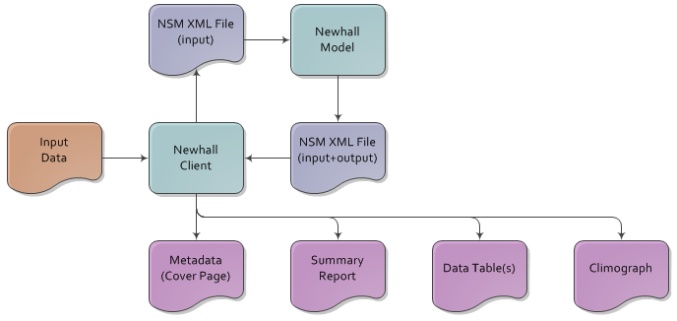

Figure . Overview of system components, inputs, and outputs.

## Input Data

Station information, metadata, preferences/options, and serially complete precipitation and air temperature data needed to run the model.

## Newhall Client

Provides a graphical user interface to set-up and run a model job. Additionally, it renders the model results file into interactive reports and graphs and spreadsheet-ready data export files.

## NSM XML File (input)

Machine-readable XML file that defines input parameters, data, and metadata needed for model run; read by Newhall Model module.

## Newhall Model

Main computational engine for Newhall Simulation; it is a port of the Van Wambeke BASIC code.

## NSM XML File (input+output)

Same XML file as above with addition of model output data; allows psuNSM users to save and share model results. File can be rendered into interactive reports and graphs by Newhall client without having to re-run computations.

## Information Products

Presentations of model input and output data that aid visual interpretation of results and format selected output for file export.

# User-System Interactions

## Set-up and Run New Single Model Job

1. Specify output file path/name.
2. Select input data source:  
   (loads saved input file preferences/settings)
   1. HCN
   2. SCAN
   3. SNOTEL
   4. CLIMOD
   5. Other
3. Confirm or edit:
   1. Units
      1. Standard (F, in, ft)
      2. Metric (C, mm, m)
   2. Location format
      1. Decimal degrees
      2. Degrees-Minutes-Seconds
      3. Degrees-Decimal Minutes
      4. Hemisphere: sign or N/S/E/W
4. Choose period of record type:
   1. Actual year
      1. Enter year
   2. Normal year or monthly average
      1. Start year
      2. End year
5. Enter station coordinates
6. Enter precipitation amount for each month
7. Enter temperature for each month
8. Enter AWC between 0-1500mm  
   (help regarding what number to set)
9. Enter metadata:
   1. Required
      1. Station name
   2. Optional
      1. Station ID
      2. Elevation
      3. Country
      4. State/Prov
      5. MLRA
      6. Contact (use default, unless user chooses to edit)
      7. Notes
10. Choose:
    1. Save job and exit
    2. Save job and run
    3. Cancel
11. If run, execute model and display summary report.

## Edit Existing Single Model Job

1. Specify job file path/name.
2. Proceed with step 2 above and review or edit selections and data values as desired.
3. Save as new file name or confirm overwrite of existing file (which will remove output data if present)

## Set-up and Run a New Batch of Model Jobs from a Spreadsheet

1. Prepare a comma-separated-value (CSV) batch file according to the format in Appendix B.
2. Specify the name/path to the CSV batch file.
3. Specify the directory to which to write job/output files.
4. Choose coordinate format:
   1. Decimal Degrees
   2. Degrees-Decimal Minutes
   3. Degrees-Minutes-Seconds
5. Choose hemisphere designator:
   1. Sign
   2. Code
6. Choose unit system:
   1. Standard
   2. Metric
7. Choose:
   1. Save job files and exit
   2. Save job files and run

## Run a Batch of Existing Model Jobs

1. Browse to directories containing NSM job files and select files to run as batch.
2. Choose:
   1. Run batch
   2. Cancel

## Create Formatted Outputs from a Model Output File

1. Browse to directory containing NSM output file and select to open.
2. File is opened in Job Summary view; choose alternative presentations:
   1. Report
   2. Climograph
   3. Export data as CSV
      1. Specify output file name/path.
      2. Select monthly data to export:
         1. Air temperature
         2. Soil temperature
         3. Precipitation
         4. PET

## Create/Edit User Profile

1. Fill-in contact information to be stored as metadata in every NSM file created by the program.
   1. Name (first, middle, last)
   2. job title
   3. organization name
   4. address (street, city, postal code, country)
   5. email address
   6. telephone number

# Workflow for Different Data/Run Scenarios

|  |  |
| --- | --- |
| Scenario | Workflow |
| single station – single run | set-up and run model job through GUI |
| single station – multiple runs | create a CSV batch file where each row defines the model data and parameters for an individual run |
| multiple stations – single run | create a CSV batch file where each row defines the model data and parameters for an individual station |
| multiple stations – multiple runs | recommend splitting into multiple batch files by station |

# Processing Flow & System Interactions

* Set-up and run new single model job
  + Cancel: client closes; no call to Model component
  + Save and exit
    1. Client saves XML model file
    2. Client closes; no call to model component
  + Save and run
    1. Client saves XML model file
    2. Client calls Model component and passes model file path
    3. Model component returns status code (0=success, 1=fail) to client
    4. If status…
       - 0, then client reads results from model file and displays Job Summary
       - 1, then client displays error
* Edit existing model job
  + Same as new single job
* Set-up/run new batch from spreadsheet
  + Cancel: client closes; no call to Model component
  + Save and exit
    1. Client parses source CSV file; creates an XML model file for each row
       - File naming convention:  
         stationName_startYear_endYear.xml
    2. Client closes; no call to model component
  + Save and run
    1. Client parses source CSV file; creates an XML model file for each row
       - File naming convention:  
         stationName_startYear_endYear.xml
    2. Client calls Model component and passes first model file path
    3. Model component returns status code (0=success, 1=fail) to client
    4. If status…
       - 0, then client calls Model component and passes next model file path
       - 1, then client displays error; prompt to continue or cancel rest of batch
    5. When last model file processed, client displays formatted output/information products screen
* Run batch of existing model files
  + Same as above Save and Run starting at step 2

# Formatted Outputs/Information Products

## Job Summary

1. Station name
2. Station ID
3. Coordinates
4. Elevation
5. Country
6. State/Prov
7. MLRA
8. Author contact information
9. Notes

## Report

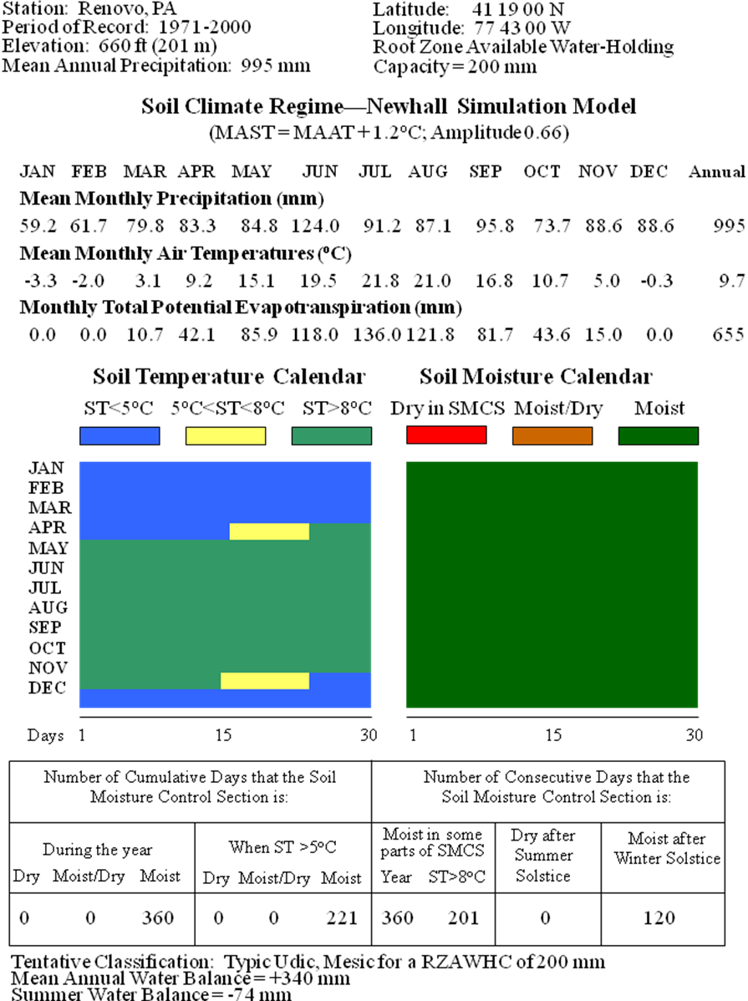

1. Monthly values of precipitation, air temperature, and evapotranspiration, in user-specified units.
2. Temperature Calendar indicating soil temperature (<5°C, between 5°C and 8°C, >8°C) by calendar day.
3. Moisture Calendar indicating predicted average soil conditions (Dry, Moist/Dry and Moist) by calendar day.
4. Number of cumulative days that the moisture control section is:
   1. Dry, Moist/Dry, Moist in one year
   2. Dry, Moist/Dry, Moist in one year when soil temperature is >5°C
5. Highest number of consecutive days that the moisture control center is:
   1. Moist in some part of the year (T>8°C)
   2. Dry after summer solstice
   3. Moist after winter solstice
6. Tentative soil climate regime classification
7. Water balance:
   1. Annual water balance = Annual P - Annual PET
   2. Summer water balance = (PJun+PJul+PAug) - (PETJun+PETJul+PETAug)

## Climograph

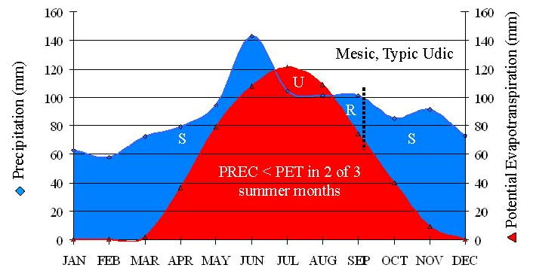

1. Chart type: area
2. X-axis: calendar months
3. Y-axis/series 1: precipitation
4. Y-axis/series 2: PET
5. Label areas under the curves:
   1. S = storage; precipitation > PET
   2. U = uptake; PET > precipitation
   3. R = recharge; amount of storage equal to uptake
6. Summary info/metadata
   1. Station name
   2. Elevation
   3. Period of model
   4. Mean annual precipitation
   5. Summer water balance = (PJun+PJul+PAug) - (PETJun+PETJul+PETAug)
   6. Annual water balance = Annual P - Annual PET

## Data Exports

CSV file with the following structure:

|  |  |  |  |  |  |  |  |  |  |  |  |  |  |
| --- | --- | --- | --- | --- | --- | --- | --- | --- | --- | --- | --- | --- | --- |
| variable | unit | Jan | Feb | Mar | Apr | May | Jun | Jul | Aug | Sep | Oct | Nov | Dec |
| airTemp | C, F |  |  |  |  |  |  |  |  |  |  |  |  |
| precip | mm, in |  |  |  |  |  |  |  |  |  |  |  |  |
| PET | mm, in |  |  |  |  |  |  |  |  |  |  |  |  |
| soilTemp | C, F |  |  |  |  |  |  |  |  |  |  |  |  |

# Client GUI Prototypes



Figure . Example data entry form for setting-up a new single model job.



Figure . Example tabbed interface for viewing different presentation formats of model results.

# Appendix A: Glossary

| *term* | *definition* |
| --- | --- |
| HCN | Historical Climatology Network is a high-quality data set of monthly averaged maximum, minimum, and mean temperature and total monthly precipitation developed to assist in the detection of regional climate change.  <http://www.ncdc.noaa.gov/oa/climate/research/ushcn/ushcn.html> |
| SCAN | Soil Climate Analysis Network is run by the USDA to monitor and record soil temperatures at a number of stations across the USA.  <http://www.wcc.nrcs.usda.gov/scan/> |
| CLIMOD | System providing web access to network of NOAA Regional Climate Centers’ data sets such as daily temperature and precipitation observations, normals and records for several thousand sites around the country and monthly data summaries.  <http://www.ncdc.noaa.gov/oa/climate/regionalclimatecenters.html> |
| SNOTEL | NRCS system that provides snowpack and related climatic data in the Western United States; SNOwpack TELemetry. <http://www.wcc.nrcs.usda.gov/snow/> |
| soil moisture control section | Soil profile zone defined by: (1) an upper boundary where dry (tension of more than 1500 kPa, but not air-dry) soil will be moistened by 2.5 cm of water within 24 hours; and (2) a lower boundary where the soil will be moistened by 7.5 cm of water within 48 hours. |
| root zone | soil profile zone from surface to a layer that has one or more physical, chemical, or thermal properties that significantly reduce the movement of water and air through the soil or that otherwise provides an unfavorable root environment. |

# Appendix B: Input Batch Data File Format

* File Type: comma separated values
* File must include required elements
* First line of file must be header of element names from table below
* Each subsequent line must contain the element data values for a single model run
* File may have only one unit system (e.g. metric and standard units may not be mixed)
* File may have only one coordinate system format

| *element name* | *description* | *required* | *data type* | *units/values* |
| --- | --- | --- | --- | --- |
| stationName | station name | Y | text (12) |  |
| latDD* | station latitude decimal degrees | * | float | deg |
| lonDD* | station latitude decimal degrees | * | float | deg |
| latD* | station latitude degrees | * | int | deg |
| latM* | station latitude decimal minutes | * | float | min |
| latS* | station latitude seconds | * | int | sec |
| latDir* | latitude hemisphere | * | text | N, S |
| lonD* | station longitude degrees | * | int | deg |
| lonM* | station longitude minutes | * | float | min |
| lonS* | station latitude seconds | * | int | sec |
| lonDir* | longitude hemisphere | * | text | E, W |
| elev | station elevation | N | int | ft, m |
| tJan | January temperature | Y | float | F, C |
| tFeb | February temperature | Y | float | F, C |
| tMar | March temperature | Y | float | F, C |
| tApr | April temperature | Y | float | F, C |
| tMay | May temperature | Y | float | F, C |
| tJun | June temperature | Y | float | F, C |
| tJul | July temperature | Y | float | F, C |
| tAug | August temperature | Y | float | F, C |
| tSep | September temperature | Y | float | F, C |
| tOct | October temperature | Y | float | F, C |
| tNov | November temperature | Y | float | F, C |
| tDec | December temperature | Y | float | F, C |
| pJan | January precipitation | Y | float | in, mm |
| pFeb | February precipitation | Y | float | in, mm |
| pMar | March precipitation | Y | float | in, mm |
| pApr | April precipitation | Y | float | in, mm |
| pMay | May precipitation | Y | float | in, mm |
| pJun | June precipitation | Y | float | in, mm |
| pJul | July precipitation | Y | float | in, mm |
| pAug | August precipitation | Y | float | in, mm |
| pSep | September precipitation | Y | float | in, mm |
| pOct | October precipitation | Y | float | in, mm |
| pNov | November precipitation | Y | float | in, mm |
| pDec | December precipitation | Y | float | in, mm |
| pdStartYr | start year of period represented by data | Y | int |  |
| pdEndYr | end year of period represented by data | Y | int |  |
| cntryCode | country FIPS code | N | text |  |
| stProvCode | state/prov FIPS code | N | text |  |
| mlraID | MLRA ID | N | text |  |
| notes | free-form notes | N | text |  |

*requirements vary by coordinate format…  
 DD: latDD, lonDD (signed values)  
 DM: latD, latM, latDir, lonD, lonM, lonDir  
 DMS: latD, latM, latS, latDir, lonD, lonM, lonS, lonDir

# Appendix C: NSM Model File Element Descriptions

| *element name* | *description* |
| --- | --- |
| stnname | station name |
| stnid | station ID |
| stnelev | elevation |
| stateprov | state or province |
| country | country |
| mlraname | MLRA name |
| mlraid | MLRA ID |
| firstname | contact person first name |
| midname | contact person middle name |
| lastname | contact person last name |
| title | contact person title |
| cntorg | contact organization name |
| address | contact street address |
| city | contact city |
| stateprov | contact state or province |
| postal | contact zip/postal code |
| country | contact country |
| cntemail | contact email address |
| cntphone | contact telephone number |
| note | free-form note(s) |
| rundate | date stamp of model run |
| nsmver | version of NSM software |
| unitsys | file unit system; metric or standard |
| lat | station latitude in signed decimal degrees |
| lon | station longitude in signed decimal degrees |
| usercoordfmt | user preferred coordinate display format; decimal degrees, degrees-decimal minutes, or degrees-minutes-seconds |
| pdtype | period of record type; actual year, normal, or monthly average |
| pdbegin | period of record begin year |
| pdend | period of record end year |
| precip | input precipitation value |
| airtemp | input air temperature value |
| smcsawc | input soil moisture control section (SMCS) available water capacity |
| lag | number of days soil temperature sine wave lags air temperature wave |
| ampltd | difference in amplitude between soil and air temperature sine waves |
| maatmast | difference, in degrees Celsius, between mean annual air and soil temperatures |
| smrclass | soil moisture regime classification computed by model |
| strclass | soil temperature regime classification computed by model |
| awb | annual water balance |
| swb | summer water balance |
| yrdry | cumulative days the SMCS is dry during the year |
| yrmd | cumulative days the SMCS is moist/dry during the year |
| yrmst | cumulative days the SMCS is moist during the year |
| bio5dry | cumulative days the SMCS is dry when soil temperature >5° C |
| bio5md | cumulative days the SMCS is moist/dry when soil temperature >5° C |
| bio5mst | cumulative days the SMCS is moist when soil temperature >5° C |
| yrmst | consecutive days the SMCS is moist in some part during the year |
| bio8mst | consecutive days the SMCS is moist in some part when soil temperature >8° C |
| smrdry | consecutive days the SMCS is dry after summer solstice |
| wtrmst | consecutive days the SMCS is moist after winter solstice |
| pet | output potential evapotranspiration value |
| soiltemp | output soil temperature value |
| stlt5 | soil temperature calendar period where soil temperature <5° C |
| st5to8 | soil temperature calendar period where soil temperature is between 5° and 8° C |
| stgt8 | soil temperature calendar period where soil temperature >8° C |
| dry | soil moisture calendar period where SMCS is dry |
| moistdry | soil moisture calendar period where SMCS is moist/dry |
| moist | soil moisture calendar period where SMCS is moist |
| begday | soil temperature/moisture calendar period begin day (1-360) |
| endday | soil temperature/moisture calendar period end day (1-360) |

# Appendix D: Example NSM XML File

<?xml version="1.0" encoding="utf-8"?>

<model version="1.0.0">

<metadata>

<stninfo>

<stnname>Renovo</stnname>

<stnid>PAXXX</stnid>

<stnelev>201</stnelev>

<stateprov>PA</stateprov>

<country>USA</country>

</stninfo>

<mlra>

<mlraname>Eastern Allegheny Plateau and Mountains</mlraname>

<mlraid>127</mlraid>

</mlra>

<cntinfo>

<cntper>

<firstname>Brian</firstname>

<lastname>Bills</lastname>

<title>Assistant Director</title>

</cntper>

<cntorg>CEI, Penn State</cntorg>

<cntaddr>

<address>2217 EES Bldg</address>

<city>University Park</city>

<stateprov>PA</stateprov>

<postal>16802</postal>

<country>USA</country>

</cntaddr>

<cntemail>bbills@eesi.psu.edu</cntemail>

<cntphone>814-865-5745</cntphone>

</cntinfo>

<notes>

<note>This is a sample NSM file.</note>

<note>This is another note in the file.</note>

</notes>

<rundate>20100412</rundate>

<nsmver>1.0.0</nsmver>

<unitsys>metric</unitsys>

</metadata>

<input>

<location>

<lat>41.3166</lat>

<lon>-77.7166</lon>

<usercoordfmt>DMS</usercoordfmt>

</location>

<recordpd>

<pdtype>normal</pdtype>

<pdbegin>1971</pdbegin>

<pdend>2000</pdend>

</recordpd>

<precips>

<precip id="Jan">59.2</precip>

<precip id="Feb">61.7</precip>

<precip id="Mar">79.8</precip>

<precip id="Apr">83.3</precip>

<precip id="May">84.8</precip>

<precip id="Jun">124.0</precip>

<precip id="Jul">91.2</precip>

<precip id="Aug">87.1</precip>

<precip id="Sep">95.8</precip>

<precip id="Oct">73.7</precip>

<precip id="Nov">88.6</precip>

<precip id="Dec">88.6</precip>

</precips>

<airtemps>

<airtemp id="Jan">-3.3</airtemp>

<airtemp id="Feb">-2.0</airtemp>

<airtemp id="Mar">3.1</airtemp>

<airtemp id="Apr">9.2</airtemp>

<airtemp id="May">15.1</airtemp>

<airtemp id="Jun">19.5</airtemp>

<airtemp id="Jul">21.8</airtemp>

<airtemp id="Aug">21.0</airtemp>

<airtemp id="Sep">16.8</airtemp>

<airtemp id="Oct">10.7</airtemp>

<airtemp id="Nov">5.0</airtemp>

<airtemp id="Dec">-0.3</airtemp>

</airtemps>

<smcsawc>200</smcsawc>

<soilairrel>

<lag>18</lag>

<ampltd>0.66</ampltd>

<maatmast>1.2</maatmast>

</soilairrel>

</input>

<output>

<smrclass>Typic Udic</smrclass>

<strclass>Mesic</strclass>

<awb>340</awb>

<swb>-74</swb>

<smcsstate>

<cumdays>

<yrdry>0</yrdry>

<yrmd>0</yrmd>

<yrmst>360</yrmst>

<bio5dry>0</bio5dry>

<bio5md>0</bio5md>

<bio5mst>221</bio5mst>

</cumdays>

<consdays>

<yrmst>360</yrmst>

<bio8mst>201</bio8mst>

<smrdry>0</smrdry>

<wtrmst>120</wtrmst>

</consdays>

</smcsstate>

<pets>

<pet id="Jan">0.0</pet>

<pet id="Feb">0.0</pet>

<pet id="Mar">10.7</pet>

<pet id="Apr">42.1</pet>

<pet id="May">85.9</pet>

<pet id="Jun">118.0</pet>

<pet id="Jul">136.0</pet>

<pet id="Aug">121.8</pet>

<pet id="Sep">81.7</pet>

<pet id="Oct">43.6</pet>

<pet id="Nov">15.0</pet>

<pet id="Dec">0.0</pet>

</pets>

<soiltemps>

<soiltemp id="Jan">-2.1</soiltemp>

<soiltemp id="Feb">-0.8</soiltemp>

<soiltemp id="Mar">4.3</soiltemp>

<soiltemp id="Apr">10.4</soiltemp>

<soiltemp id="May">16.3</soiltemp>

<soiltemp id="Jun">20.7</soiltemp>

<soiltemp id="Jul">23</soiltemp>

<soiltemp id="Aug">22.2</soiltemp>

<soiltemp id="Sep">18</soiltemp>

<soiltemp id="Oct">11.9</soiltemp>

<soiltemp id="Nov">6.2</soiltemp>

<soiltemp id="Dec">0.9</soiltemp>

</soiltemps>

<calendars>

<tempcal>

<stlt5>

<begday>1</begday>

<endday>105</endday>

</stlt5>

<st5to8>

<begday>106</begday>

<endday>116</endday>

</st5to8>

<stgt8>

<begday>117</begday>

<endday>316</endday>

</stgt8>

<st5to8>

<begday>317</begday>

<endday>326</endday>

</st5to8>

<stlt5>

<begday>327</begday>

<endday>360</endday>

</stlt5>

</tempcal>

<moistcal>

<moist>

<begday>1</begday>

<endday>360</endday>

</moist>

</moistcal>

</calendars>

</output>

</model>